# Genetic correlations between sites via fully random-effects model

In this approach, we create subsets of our plot data. Each subset contains the information of only two sites. Since we have 10 sites, there are 45 different site pairs and thus 45 subsets we need to analyze. For each subset, we fit a model that allows for a genetic correlation between sites as:

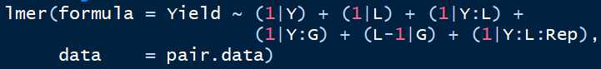 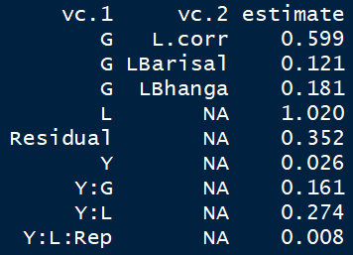

As a result e.g. for the site pair Bharisal-Bhanga we obtain the variance component estimates above. This pair has a genetic correlation of 0.599. After looping through all 45 site pairs, we obtain these genetic correlations:

